APPENDIX A
PHOTOGRAPHS TAKEN DURING JIV AT 8” PIRIGBENE-OBAMA PIPELINE AT EPEBU COMMUNITY, OGBIA L.G.A, BAYELSA STATE.ON 23RD MARCH, 2024.
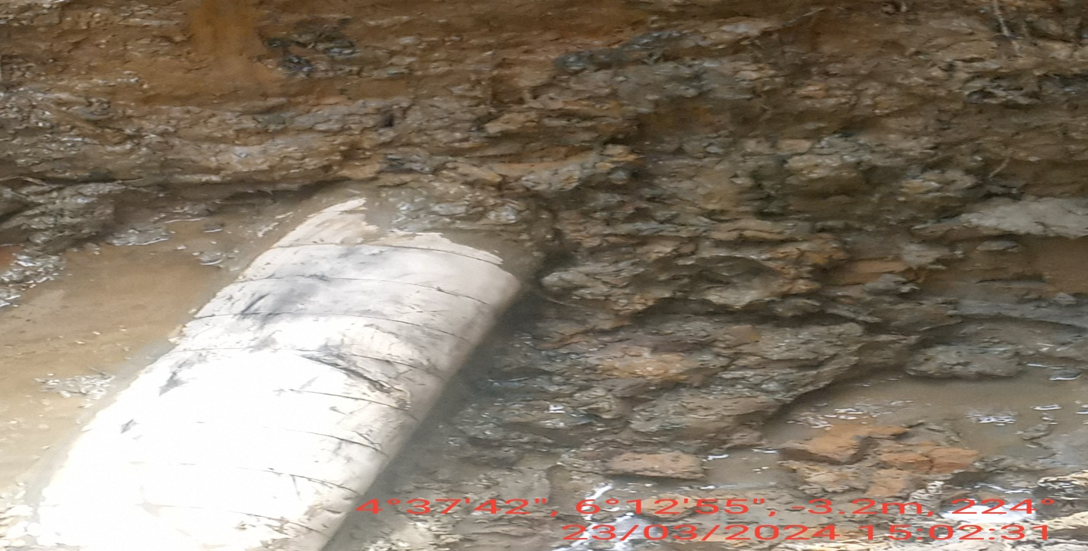
Fig. 1: About 100mm cut made between 9 -11 o’ clock position of the pipeline by Vandals. 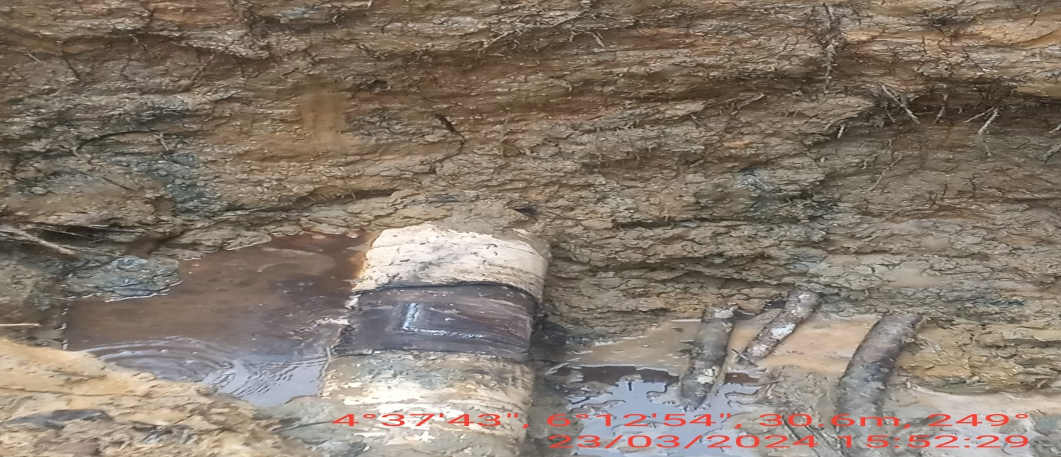
Fig. 2: The incident point after repair has done.

